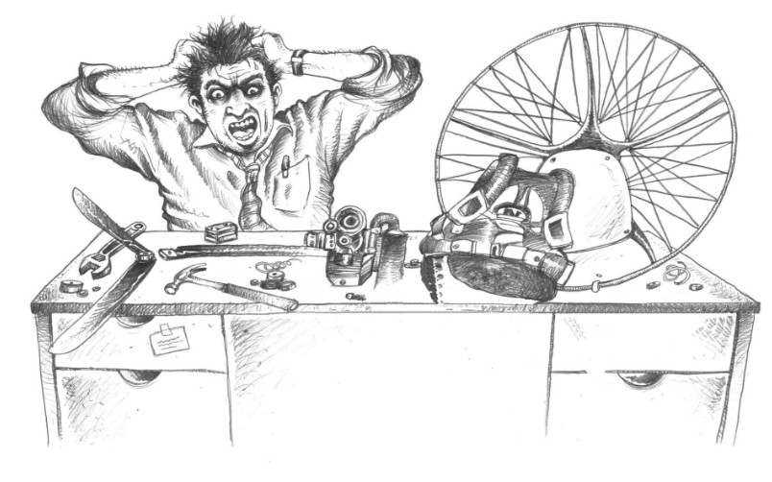

Horsepower, thrust and RPM: engine, reduction drive and a 130 cm propeller
Technical note for instructors and pilots · Version 1.0 · 30 October 2026
Paramotor SA (Pty) Ltd t/a Apex Adventures · SACAA DTO 0012

Technical notes · General

Scope. How engine horsepower becomes thrust, and how engine rpm, the reduction drive (gearbox) and a fixed-pitch propeller work together. The worked example uses a 130 cm propeller and the Vittorazi Moster 185 with its two published reductions. Thrust figures from the maker are quoted as published. Everything marked calculated is our own estimate from standard theory and is not a measured result. The engine and propeller manuals always win.

1. The short answer
- Horsepower is a rate of doing work. Thrust is a force. They are linked, but not the same thing. Power = force × speed.
- At a standstill (takeoff) thrust comes from how much air the propeller can push, not from rpm alone. A bigger disc moving more air more slowly gives more thrust from the same horsepower.
- A fixed-pitch propeller only matches one engine rpm and power point. Change the diameter, pitch, altitude or temperature and the engine settles at a different rpm.
- The reduction drive does not add power. It turns fast, low-torque engine rotation into slow, high-torque propeller rotation. The propeller needs that because a 130 cm blade cannot spin at 8,000 rpm (section 5).
- Thrust falls as you speed up. The big static number on the data sheet is a takeoff number, not a cruise number (section 8).

2. Horsepower is not thrust
Term | What it is | Unit
Power (hp, kW) | How fast the engine can do work | 1 hp = 745.7 W
Torque | Twisting force at the shaft. Power = torque × rotation speed | Nm
Thrust | Forward force the propeller makes | N or kgf (1 kgf = 9.81 N)
Static thrust | Thrust with the aircraft not moving (a takeoff condition) | kgf

Two engines of the same horsepower can give different thrust, because the propeller and the reduction decide how well the power is turned into a stream of air. The forum thread we checked says the same in plain words: power is set by the engine, and the prop and rpm decide how much becomes thrust (paramotorclub.org, forum opinion, not a measurement).

3. From horsepower to thrust: the 130 cm example
The simplest model treats the propeller as a disc that speeds up the air passing through it (momentum, or actuator-disc, theory). For a propeller that is not moving forward the ideal thrust is:
T = ( 2 × ρ × A × P² ) ^ (1/3)
where ρ is air density (1.225 kg/m³ at sea level, 15 °C), A is the disc area and P is power at the propeller. This is the ideal upper limit. Blade drag and tip losses mean real thrust is lower (Virginia Tech course notes use about 90 % of the ideal value for a good propeller; ours are lower, see below).
Disc area for 130 cm: A = π × 0.65² = 1.327 m²
Power at prop | Ideal static thrust, 130 cm (calculated)
10 hp | 57.6 kgf
15 hp | 75.5 kgf
20 hp | 91.5 kgf
25 hp | 106.2 kgf
30 hp | 119.9 kgf

Check against a published figure. Vittorazi publishes 78 kgf static thrust for the Moster 185 with a 130 cm two-blade propeller at 8,500 rpm (and 75 kgf with a 125 cm propeller). The engine is 25 hp at 7,800 rpm. Against the 106 kgf ideal figure, 78 kgf is about 73 %. That is a sensible real-world result, and it shows why the ideal figure is a ceiling, not a promise. (The 73 % is our calculation from two published numbers. Vittorazi does not give the power at 8,500 rpm.)
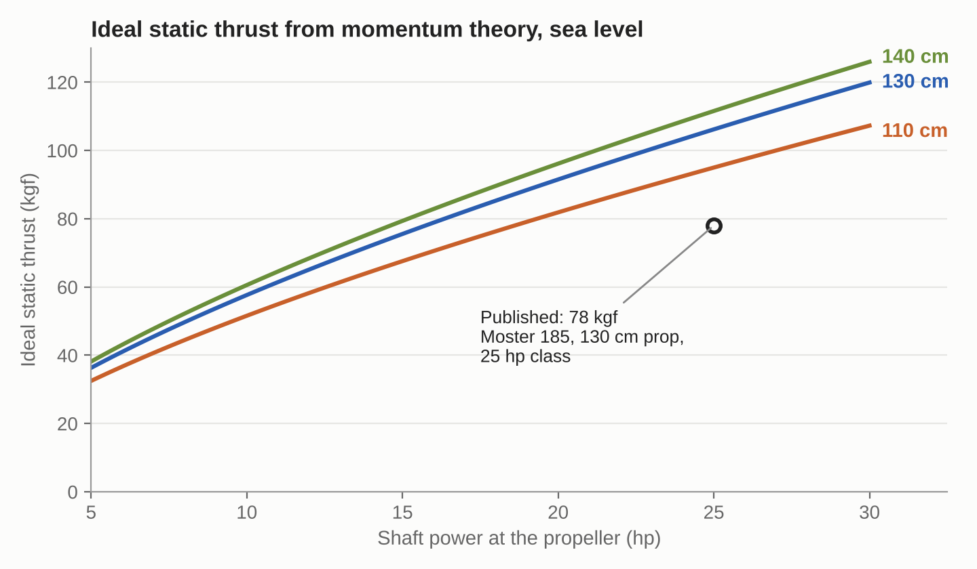
Ideal static thrust against shaft power for 110, 130 and 140 cm propellers (calculated, sea level). The circle is Vittorazi's published figure. Real thrust sits below the ideal lines. Apex chart.
Two lessons from the formula:
- Thrust grows with power to the power of two-thirds, not in proportion. Twice the horsepower gives only about 1.6 times the thrust.
- Thrust grows with diameter to the power of two-thirds as well. At 25 hp the ideal thrust is 95 kgf for 110 cm, 106 kgf for 130 cm and 112 kgf for 140 cm. Going from 110 to 130 cm is worth about 12 %. That is why paramotors use big, slow propellers.

4. RPM and the fixed-pitch propeller
A fixed-pitch propeller has blades set at one angle. It cannot change its bite as you fly. What happens next is a balance:
- The propeller absorbs power that rises very steeply with rpm and diameter. In the standard propeller laws it goes with rpm cubed and diameter to the fifth power.
- The engine delivers power that peaks in a certain rpm range.
- The engine speeds up until the power it makes equals the power the propeller absorbs. That crossing point is your full-throttle rpm.
If the propeller is… | The engine… | Result
Too small or too little pitch (absorbs too little) | Revs past its power peak | High rpm, less thrust than possible, more noise, risk of over-revving
Right for the engine | Reaches its rated rpm at full throttle | Rated power and best thrust
Too big or too much pitch (absorbs too much) | Cannot reach its power rpm | Low rpm, low power, high load and heat on the engine

Forum guidance is that pitch is tuned within the rpm range that diameter allows, so that the engine can still reach its rpm (paramotorclub.org). Do not choose a propeller by diameter alone. Use the combination the engine maker or the Apex propeller list gives for the engine and reduction.

5. The reduction drive and tip speed
The engine spins at thousands of rpm. The propeller spins at about a third of that. The drive between them is the reduction ratio:
Propeller rpm = engine rpm ÷ ratio
The Moster 185 has two published ratios: 1 : 2.68 (the common one, suited to propellers roughly 115 to 130 cm) and 1 : 2.87 (for larger propellers, roughly 125 to 140 cm). The pulley shows 128 for 1 : 2.68 and 130 for 1 : 2.87. With the same aerodynamic profile the two give very similar static thrust, and 1 : 2.87 gives lower propeller rpm at the same engine rpm. (Vittorazi FAQ.)
Worked example, Moster 185 on a 130 cm propeller (calculated):
Item | 1 : 2.68 | 1 : 2.87
Engine rpm | 7,800 | 7,800
Propeller rpm | 2,910 | 2,718
Tip speed (π × 1.30 m × rpm ÷ 60) | 198 m/s (713 km/h) | 185 m/s (666 km/h)
Tip Mach number (speed of sound 340 m/s) | 0.58 | 0.54
Engine torque at 25 hp, 7,800 rpm | 22.8 Nm | 22.8 Nm
Propeller torque (ignores gearbox losses) | 61 Nm | 66 Nm

What the table shows:
- Power stays the same. Torque goes up by the ratio and rpm goes down by the ratio. That is all a reduction drive does. A real gearbox loses a little power as heat. Vittorazi gives no figure.
- Tip speed is the limit on diameter. A forum rule of thumb is to keep tips at about Mach 0.5 to 0.6 for efficiency and low noise (paramotorclub.org, a forum opinion). Above that, noise and drag rise sharply. The 130 cm propeller at 7,800 rpm sits at the top of that band on 1 : 2.68 and just inside it on 1 : 2.87.
- Why the longer ratio (1 : 2.87) suits bigger propellers: it slows the propeller so the larger tips stay inside the speed limit.
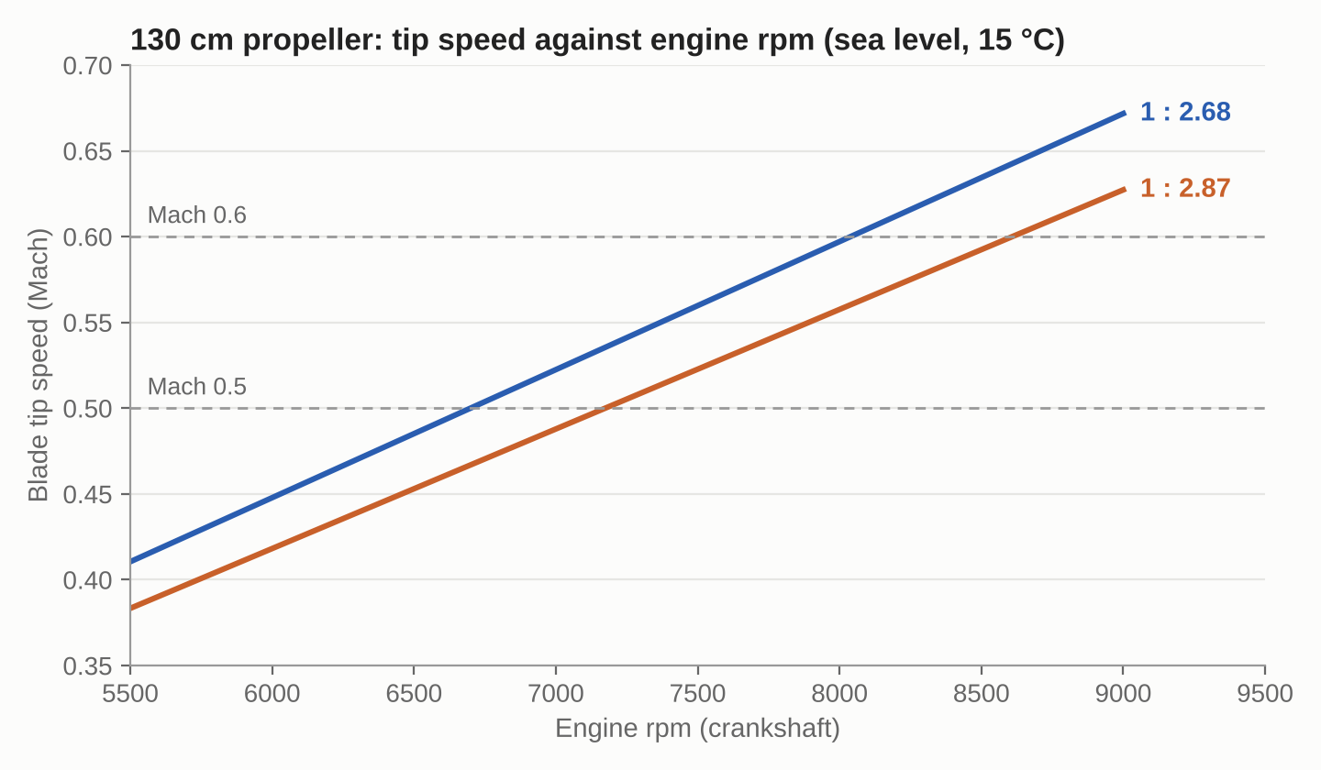
Blade tip speed of a 130 cm propeller against engine rpm for the two Moster 185 ratios (calculated, speed of sound 340 m/s). Apex chart.
At 8,500 engine rpm (the speed Vittorazi quotes its thrust at) the same 130 cm tip speed is Mach 0.63 on 1 : 2.68 and Mach 0.59 on 1 : 2.87. Both are calculated by us. Check the actual engine and propeller limits in the manuals.

6. Diameter, pitch and what to expect
Change | Effect on static thrust | Effect on engine | Note
Bigger diameter, same power | Thrust up (about two-thirds power law) | Loads the engine much more (diameter⁵) | Needs a lower-rpm ratio so the tips stay within speed
Smaller diameter | Thrust down | Engine revs higher | Higher tip speed if rpm is held
More pitch | More load at a given rpm | Engine rpm falls | Can trade thrust for speed. Too much overloads the engine
Less pitch | Engine revs up | Easier on the engine at low speed | May over-rev if the rest is unchanged

Pitch values for specific propellers are listed by the propeller makers. Do not change a propeller without checking the engine maker's propeller list and getting CFI approval.

7. Density altitude takes both power and thrust
Hot, high air has less oxygen for the engine and less mass for the propeller to push. Both hurt. This table uses the thrust formula (thrust ∝ power^⅔ × density^⅓) and the engine power loss of about 3 % per 1,000 ft of density altitude used in our Density Altitude note. It is a rough, calculated guide and holds the propeller rpm unchanged. It is not a measured result.
Density altitude | Air density (of sea level) | Engine power (about) | Static thrust (about)
Sea level | 100 % | 100 % | 100 %
2,000 ft | 94 % | 94 % | 94 %
4,000 ft | 89 % | 88 % | 88 %
6,000 ft | 84 % | 82 % | 83 %
8,000 ft | 79 % | 76 % | 77 %

A fixed-pitch propeller unloads in thin air and the engine revs up a little, which wins back some power. That is not included above. Carburettor mixture also changes with density. See the Walbro WB37C note and the Density Altitude note. A pilot at 6,000 ft density altitude has roughly one fifth less takeoff thrust than at sea level and a longer ground run.

8. Static thrust is not flying thrust
Thrust falls as airspeed rises, because the propeller is working on air that is already moving. Useful power is thrust × speed, and the engine must also overcome the propeller's own losses.
Illustrative example (assumed numbers, not measured): to hold 40 km/h (11.1 m/s) the wing and pilot might need about 25 kgf (245 N) of thrust.
- Useful power = 245 N × 11.1 m/s = 2.7 kW = 3.6 hp
- If the propeller is 60 % efficient (assumed), the engine supplies about 6 hp
That is a quarter of a 25 hp engine. This is why a paramotor flies on part throttle, and why a big static thrust figure matters mostly for the takeoff run, climb and flying out of trouble. The forum thread notes that a calculator made for model aircraft overstates airspeed for a paramotor, because the paramotor has far more drag.

9. Apex engine and propeller record
Fill in from each engine's manual and the propeller maker's data. Row 1 is from Vittorazi's published page and is to be confirmed against the MY25 manual.
Engine | Ratio | Prop (diameter, blades) | Rated hp / rpm | Max engine rpm | Static thrust (maker) | Source
Vittorazi Moster 185 | 1 : 2.68 | 130 cm, 2 blades | 25 hp / 7,800 |  | 78 kgf at 8,500 rpm | Vittorazi page. Confirm in manual
Vittorazi Moster 185 | 1 : 2.68 | 125 cm, 2 blades | 25 hp / 7,800 |  | 75 kgf at 8,500 rpm | Vittorazi page. Confirm in manual

Propeller change record
Date | Engine and ratio | Propeller fitted | Static rpm checked | Hours | Done by | CFI check

10. Sources and cautions
- Moster 185 (Vittorazi, vittorazi.com). 25 hp at 7,800 rpm, ratios 1 : 2.68 to 1 : 2.87, static thrust 78 kgf (130 cm) and 75 kgf (125 cm) at 8,500 rpm.
- What is the difference between the two reductions of the Moster185 (Vittorazi FAQ, vittorazi.com). Ratio and propeller range for each.
- Performance 10. Thrust Models (Virginia Tech AOE 3104 course notes, archive.aoe.vt.edu). Momentum theory for static thrust, ideal against practical value.
- Thrust calculator (paramotorclub.org forum thread 8445). Forum opinions on tip speed at Mach 0.5 to 0.6, pitch tuning and the drop in thrust with speed. Not a technical authority. Used only for rules of thumb, marked as such.
- Propeller power and thrust scaling (power with rpm cubed and diameter to the fifth) is standard propeller theory, taught in the NASA and university propeller notes. Not taken from a paramotor publication.
- Apex Density Altitude Technical Note (3 % per 1,000 ft engine power loss).
Cautions.
- The thrust curves and the 73 % figure are calculated by us, not measured. They are for teaching the relationships, not for choosing a propeller.
- The Vittorazi ratio and thrust figures are from the maker's web page.
- Maker thrust figures are static, at one rpm, on a test stand. Do not read them as flying thrust.
- Never change the propeller, reduction ratio or engine settings without the maker's approved combination and CFI approval. A wrong combination can overload or over-rev the engine, or put the tips above safe speed.
- This note is a technical aid. It does not replace the manufacturers' manuals or the DTO's procedures.

